Memorandum
To: Top Management
From: Tasty Tea
Date: February 19
Re: Performance Evaluation System

Performance evaluation is a daunting, yet crucial aspect of-of operating a business. Not only does it motivate employees to improve performance, but it also enables management to identify areas of operating excellence or areas for improvement. A capable performance evaluation system sets great corporations apart from the average corporations. It allows the entire organization to improve and grow collectively.

Thus, the best performance evaluation system is one that aligns with the needs and values of the organization itself. For Tasty Tea, the Balanced Scorecard Method (BSM) and 360 Degree Feedback provide the most useful performance metrics in holistically evaluating company operations. The BSM aims to assess the firm based on four diverse areas: financial, customer satisfaction, internal business processes, and learning & growth. Below is a flowchart showing the relationships of these metrics.
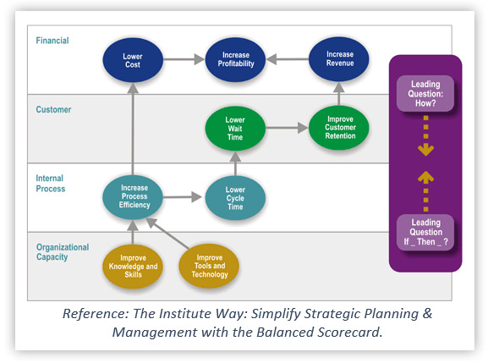

The 360 Degree Feedback focuses on evaluating employee performance throughout the organization. Together, these evaluation systems provide useful feedback for both the employee and the company as a whole.

Financial
Evaluating our financials is a top priority at Tasty Tea. There are two areas we analyze to increase, sales growth and return on equity. To measure our sales growth, we place benchmarks on the percentage of sales from new customers and our market share. We will target 25% of sales to come from new customers, while we aim for a 2.5% market share. The benchmarks used to test our return on equity will be the percent of projects with actual positive NPV vs. predicted, and net income growth year over year. We will target for 75% of projects with actual positive NPV vs. predicted. We will also target a 5% increase in net income growth year over year.

Customer Satisfaction
Customer Service is highly valued at Tasty Tea, as our customers are what drive our company. Although the company feels we have outstanding customer service, there is always room for improvement with each customer. One way to improve customer service would have surveys through our website that will help up more clearly understand what customers do and do not like about the products. Another would be to evaluate the number of customer complaints per day. Along with this, we would like to improve our response time to fix the issues customers have with the products.

Internal Business Processes
For the processes, there are a few benchmarks that the company would like to meet to keep the inventory in the warehouse for the shortest period as possible. We want to emphasize on average days in queue and total time from process beginning to end. For ordinary days in the queue we would like to have it around no more than 3.2 days. This will make it, so the tea is not sitting for very long and out for shipment as soon as possible. The company would also like to have the total process to last no longer than ten days from the time of receiving supplies to the time of shipment. Between these two goals, it will allow the team to be efficient in our production and shipment departments.

Learning and Growth
Learning and growth within the company are valued highly. We believe there are a few things that we can do to improve personal growth for our employees. We want to develop our training programs to expand the knowledge of our employees. The company would like to implement virtual and physical training that will help with things from knowledge about tea to the process and even the logistical side of the business. This will help our employees be more well-rounded and prepared to take on any task within the company. The company believes that with this improvement of training it will also result in a reduction of employee turnover.

360-Degree Feedback
Employee evaluation plays a significant role in cooperation. On the one hand, the assessment allows top managers to identify the strengths and weaknesses of their employees. Based on this evaluation, managers can provide useful suggestions about how to improve. In future work, managers can formulate and assign tasks effectively and rationally. On the other hand, this evaluation gives employees the opportunity to show their contributions, and they can be recognized. The employees who perform well can be motivated and be more enthusiastic in their work.

This memo has provided you with details on our idea about our performance evaluation system. If you have any questions about the system that we designed, please send us an email at vll@iastate.edu, btbatton@iastate.edu, cside32@iastate.edu, ouyang@iastate.edu.

Regards,

Taste Tea – Management Team

References:
Balanced Scorecard. (2017). Strategy Mapping. Balanced Scorecard.org. Picture. Retrieved from: https://www.balancedscorecard.org/portals/0/images/2017/strategymapping.gif

Becker Professional Education. (2018). CPA Exam Review Course: Business Section 3, Module 4. Version 3.2. Skills practice. Retrieved from: https://online.becker.com/module/B-03- 04/v3.2/skillsPractice

Johnson, R. (2018, June 29). Advantages and Disadvantages of Performance Evaluation. Retrieved from https://smallbusiness.chron.com/advantages-disadvantages- performance-evaluation-21143.html

