Performance Evaluation Report
The following report applies the Tasty Tea™ performance evaluation system for the fiscal year ended December 31, 2019. This report utilizes the company’s balanced scorecard to evaluate the performance of the firm and management in four major areas: financial, customer satisfaction, internal business processes, and learning & growth. Further, we aim to identify areas where management and the firm has met, exceeded, or not reached pre-defined performance objectives. We will also evaluate the effectiveness of our 360-feedback system. Based on these outcomes, we will identify appropriate bonus amounts and recipients.

Financial performance
As stated earlier in the year, our financial performance evaluation is top priority each year. Our financial performance benchmarks dealt with net income growth, projects with positive NPV, market share, and new customer sales. These measurements help the company see how well we believe the company is doing financially. Based on our calculations, three out of the four categories exceeded our expectations. Although those three show signs of improvement, the company will have to look at why our net income growth was negative. This will need to be a focal point of discussion for next year, as we do not want to have a negative year over year trend. In addition, we will also want to discuss how the company can continue growth in the other three categories to ensure constant improvement in all categories.

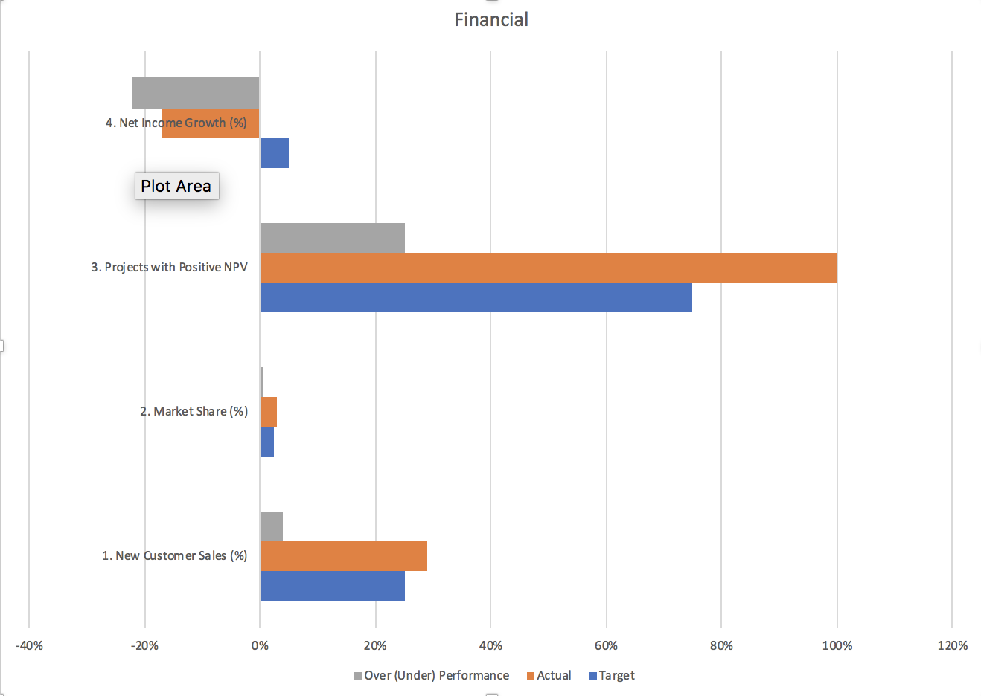

Customer satisfaction
Our customer-centric culture is one of the reasons that makes Tasty Tea such an incredible company. As such, we did an outstanding job delivering value for our customers. As you are aware, we utilize a customer satisfaction survey to gauge the feedback from our customers. Based on feedback received from the survey we have two performance metrics that measure if we are successfully meeting our customer’s needs. The survey contains both quantitative and qualitative information related to our products and service. Both performance metrics use quantitative information in their calculation. The marketing department carefully reviews the qualitative information and summarizes on a monthly basis for leaders of other departments.

The first customer satisfaction performance metric is the average customer satisfaction score. This is calculated by dividing the total sum of quantitative scores by the total number of scores. We set a target for an average customer score of 3.5 and we are proud to announce that we exceeded our target receiving an actual score of 4.5. In our first few months of operations, we noticed that our customers loved our quality and packaging. They consistently rated their satisfaction a 5 in those categories. However, our prices are a little higher than they liked. As a result, the marketing manager introduced sales promotions and discounts in the second quarter. Since then the average customer satisfaction score remained high throughout the remainder of the year.
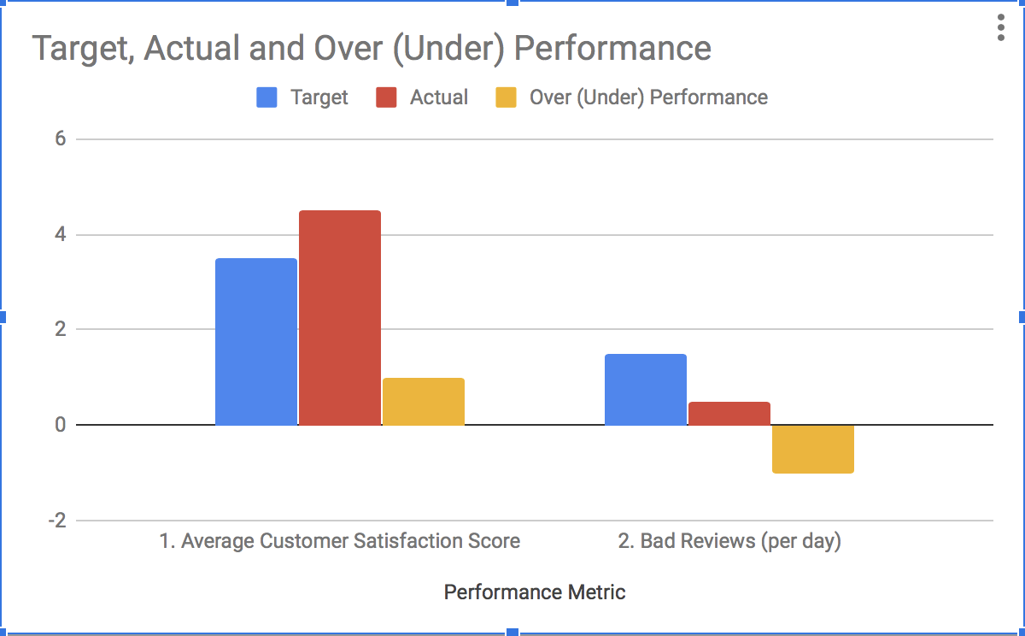
The second metric is the number of bad reviews per day. This metric is incredibly important to use because we never want a customer to have a “bad” experience with our products. This metric helps us quickly spotlight and rectify areas where the company is not performing well. Bad reviews per day are calculated by dividing the total number of reviews below one by 365 (number of days per year). We set the target of 1.5 bad reviews per day and exceeded our expectations by actually receiving 0.5 bad reviews per day. This is far below the acceptable standard. Our team achieved this target because of the same reasons for our customer satisfaction metric. Management's quick responsiveness to early bad reviews allowed us to make the appropriate adjustments to improve customer satisfaction through the rest of the year. Offering sales discounts and promotions early in the fiscal year, substantially lowered the number of bad reviews for the rest of the year.

Internal business process
We here at Tasty Tea wanted to ensure the proper handling and care of our inventory. After one year of operations, I am proud to report that we exceeded our targets for internal processes. As you know, to gauge how effective our processes are we examine two quantitative factors. The production department, then carefully reviews their findings and summarizes on a monthly basis for leaders of other departments.

The first internal business process factor is average days in queue. This is calculated by dividing the total inventory by the total amount of COGS. This number is then multiplied by 365. Our set target for average days in queue was 3.2 and we are proud to announce that we exceeded this target with an actual average days in queue of 3. Our total ending ending inventory decreased but our COGS increased, however, this increase was not as great when compared to the decrease of our inventory. In our first year of operation, we sold more product than we originally expected. This resulted in a lower ending inventory which directly contributed to less time spent in the inventory queue.

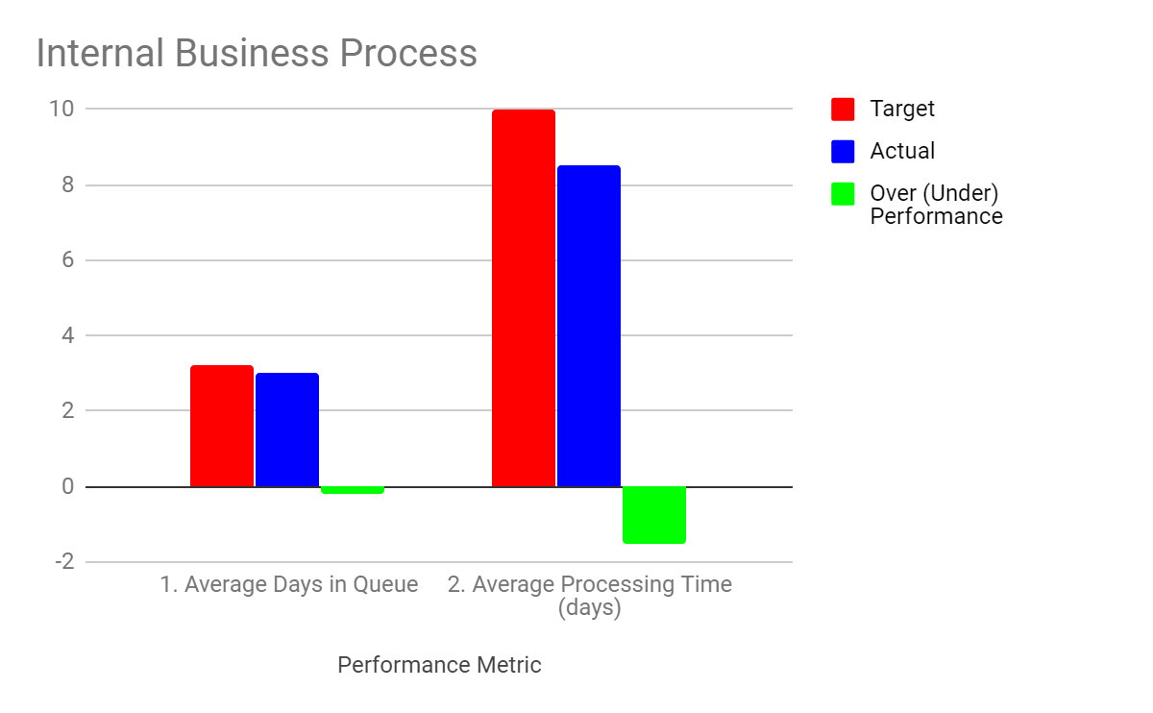

The second internal business process factor is average processing time (days). This is calculated by dividing the total processing time by the total units manufactured. We set a target for average processing time of 10 days and it is with great pleasure we announce we exceeded this target with an actual average processing time of 8.5 days. The processing time for our products remained constant throughout the year. We increased our total units manufactured to match the demand for our products. This ultimately resulted in a lower average processing time for our products which we will look to continue on this success for next year.

Learning & Growth
After reviewing our actual results, it’s clear that learning & growth is an area for improvement. In particular, our unfavorable labor efficiency variance is seven-times greater than our projected amount. As such, this is a reflection of failing to meet employee training goals. We ambitiously set the target for each employee (on average) to attend four training sessions throughout the year. Actual results show that each employee went to approximately one and a half training sessions throughout the year.

These training sessions are designed to help employees fulfill their role more efficiently and effectively. They aim to give employees the intellectual tools to perform their job to the best of their abilities. Unfortunately, our master budget projected direct labor costs under the assumption employees attend the target amount of sessions. Looking a little closer at where our management team has fallen short, we have determined that there is no incentive or disincentives for attending these sessions. Human resources (HR) who is responsible for tracking and scheduling each employee’s training does not enforce punishment for failing to attend training; nor do they have a reward for employees who attend additional sessions. This is certainly an area where we will look to improve going forward.
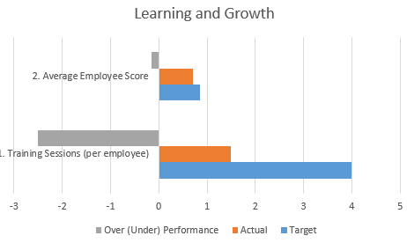
At the end of these training sessions, employees take a quiz to to gauge their knowledge of their role within the organization. Since our employees went to 1.5 sessions rather than the four we set the target at, we expect their scores to be lower than we set the target. In fact our employees scored an average of 70%, instead of the set target of 85%. When examining our direct labor efficiency variance we noted that our employees are not as efficient as we would like them to be. This could be a result of lack of time management, lack of experience, or our training program is not as effective. As stated earlier in the training sessions paragraph, employees are not incentivized to attend the proper amount of training sessions. It is more than likely that our employees are less efficient because of the lack of training.

360-degree feedback
Self-evaluation is a major component of Tasty Tea. At the end of the year, employees will receive three forms to fill out. They will evaluate themselves, evaluate their supervisor, and evaluate the direct reports. After all three forms are filled out employees will meet with their supervisor to discuss. This feedback system allows employees to show their contributions and be recognized for them. It also allows managers to identify the strengths and weakness of their employees. Managers will be able to provide useful suggestions about how to improve these areas of weakness, based on the evaluation. After reviewing the supervisors’ assessments we conclude that employees have less knowledge than we would like. Employees have discussed they are working longer hours than originally expected, however, their salary is higher so it is not much of a problem. A few employees suggested a reward system to incentivize training sessions and and a passing score on the quizzes taken afterwards. For this company to better operate next year, we need to improve the overall knowledge and efficiency of our employees.

Bonuses & compensation
According to our compensation policy, managers will receive bonuses based on their performance throughout the year. As such, we evaluate performance by comparing the target metric to the actual results. Managers who meet expectations receive a 2.5% bonus, while who exceed targets receive a 5% bonus. The aligns the objectives of management with the organizational goals. Managers who do not meet target goals are not awarded a bonus. Below is a table of managers, performance metrics, and bonus amounts for managers who exceeded expectations:

Performance Metric | Manager
New Customer Sales | Sales
Market Share | Marketing
Projects (positive NPV) | Product development
Avg. Days in Queue | Production
Avg. Processing Time | Production
Avg. Customer Satisfaction | Customer service
Bad Reviews (per day) | Customer support

