Assignment #4

Final Project – Final Project Due Dead Week; Reflection due by 7 PM of Final Day
In order to analyze pop culture and media, it can be very helpful to gain experience composing it. As a way to help you become more critical analysts of popular culture, this project asks you to compose some kind of media that would engage a specific audience. Below are your options for this project, as well as examples of possible audiences. Please note that if you are an active consumer of the media you choose to produce, and know of a different audience, you may cater to that one specifically. There will be space for you to write about it in the pitch.

Your media should pursue one or more of the following goals:
- Persuading your audience to understand the topic (or source texts if you’re doing a remix) in a new way, noticing aspects of the text(s) that are usually overlooked.
- Making the topic or source text appealing to an audience different from the one for which it was intended.
- Offering critical commentary about a figure or issue.

Video
This should be 3 - 5 minutes of footage. Some genres to consider are:
- Video Remix (re-edit clips to satirize a figure or comment on an issue)
- Commentary Vlog (share your thoughts on political or popular culture topics, perhaps including clips from original media)
- Video Response (Make a video that responds to another YouTube video)
- Public domain remix (Make a new movie using public domain footage from the Prelinger archive or internet archive)
- Re-cut television show / movie trailer (edit movie tv clips to tell a different story than intended)
- Music Video (make a music video using found footage or original footage)
- Cultural Commentary Remix (compile a series of related clips to highlight a cultural phenomenon)
- Let’s Play (record yourself playing an online game or other online text and add analysis as an audio layer)
- Parody tutorial
- Genre of your choice (find a “genre” of YouTube video, tell me about it, and then make it; you probably know about cool things I haven’t even heard about)

Game
This should be either a continuation of the game you created for our game jam, or a game project that is small scale. Options include:
- Reskinning (Monopoly becomes Game of Thrones Monopoly) a game to create an argument about that game or the topic it now embodies.
- Creating an argument from the aesthetics of board/card games
- Producing a small scale board or card game that critiques one pop culture text

Podcast
This should be a grand total of 15 minutes of audio. You may do this in 2-5 episodes. Listen to The Weird History podcast or Aaron Mahnke’s Cabinet of Curiosities to get an idea of how to do “snippet” form podcasts. Must include your own original podcast art.
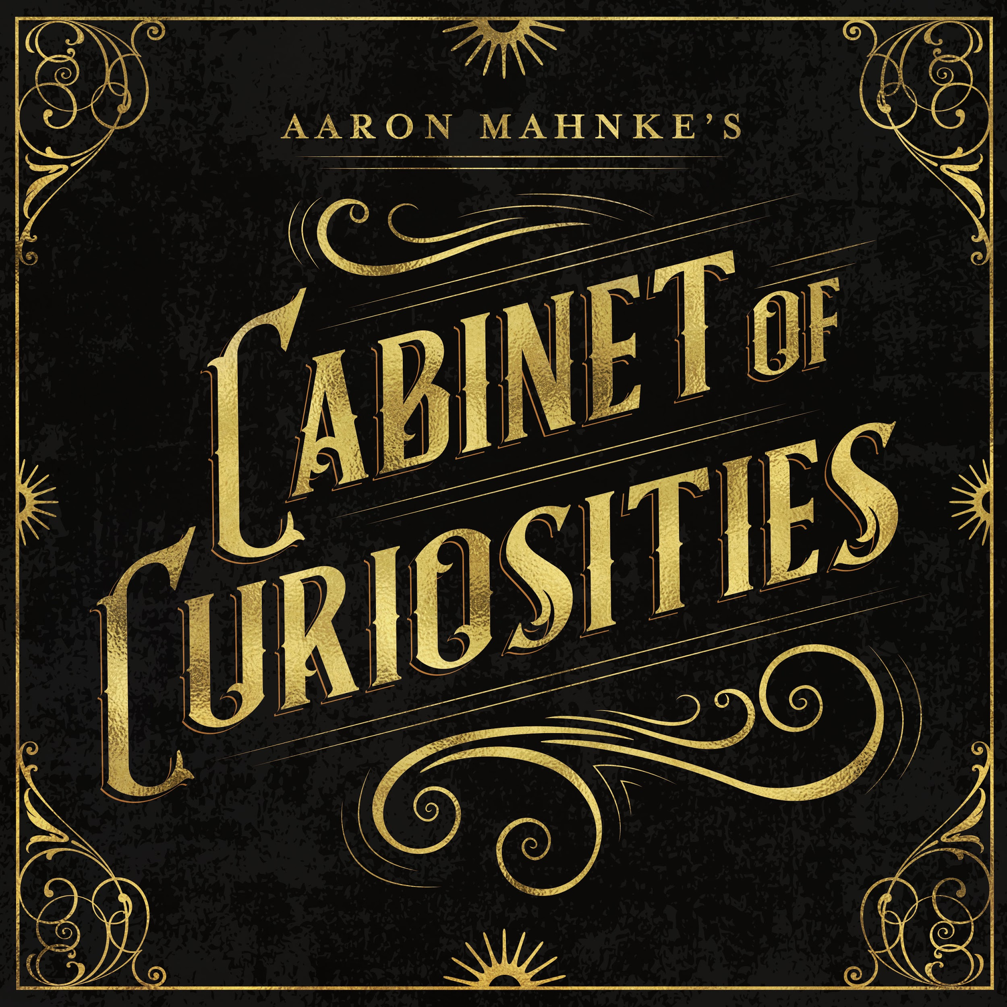

Social Media Project
Disclaimer: DO NOT use your own personal social media account(s) for this project. It should be a project account specifically. For this, you should have at least 15 posts. You may use whichever social media platform you’d like, except Mastadon (because then I would have to join specific servers to look at your project) or Pillowfort (because I’m on the waiting list and again, wouldn’t be able to see your project). Remember that whatever you choose, you’re trying to use a critical framework to make an argument. Good examples of these would be:
- Barbie Savior - a satirical Instagram account that pokes fun at white savior tourism.
- 70s Dinner Party - an archival Twitter account that features commentary on recipes from the 70s.

Evaluation Criteria

Pitch __/10 pnts
Due on website Friday, Nov. 8th - Write no more than one single-spaced page about your plan for your project. Indicate what genre you’ll compose. You may include an outline, storyboard, or other way to account for your plan. Report on the work you’ve accomplished so far.
- Which media are you producing?
- What is your pop culture topic or text?
- What is your argument?
- What critical lens are you using to discuss this topic?

Beta __/20 pnts
Due on website before class Wednesday, Nov. 20th - Post an update on what you have done, as well as whatever you have of your project. If you only have 30 seconds of video, post that 30 seconds. If you have your game board done, post that. We will use Wednesday and Friday to offer feedback to our classmates. Link to the social media project if that’s what you’ve chosen to do.
- Did you post your beta draft?
- Did you offer feedback to at least 6 peers?

Media __/60 pnts
Due during Dead Week - we will present our finalized projects during Dead Week. Depending on how many people have which kinds of projects, we will watch videos Monday-Wednesday, podcasts and social media projects will go Wednesday, and games will be played on Friday.
- Does your media hold a clear argument?
- Can we tell which critical lens(es) you’re using?
- Is it uploaded to your website?
- Does it pursue one of the stated goals (top of this assignment sheet)?
- Does it follow the assignment specifications, or approved assignment modifications?

Reflection __/10 pnts
Due at 7 PM the night of the final - Write a reflection of ~500 words. This should answer the following questions:
- Why did you choose this type of media over the other options. Try to dig deeper than simply “I like it”. Why is it appealing? What does it offer both designer and consumer?
- Who is the audience and what is the rhetorical purpose for your media? What action will you take (or could you take) to reach a wider audience with this media?
- What is the genre of your media? Not just “video” or “game” but what type does it fall into? How does your media both build upon and *extend* the rhetorical moves of other media of its type?
- What kinds of ethical choices did you make about intellectual property and fair use? Is there/would there be a risk that your media may be removed from its platform and if so why are you willing to take that risk? (Defend your choices and cite the readings to support your point of view.)
- How has the experience of composing this media caused you to think about or rethink concepts of pop culture analysis and participatory media?
- How did you revise this media based on feedback from peers (in and out of class) or the instructor? If you had more time, what would you further revise?

